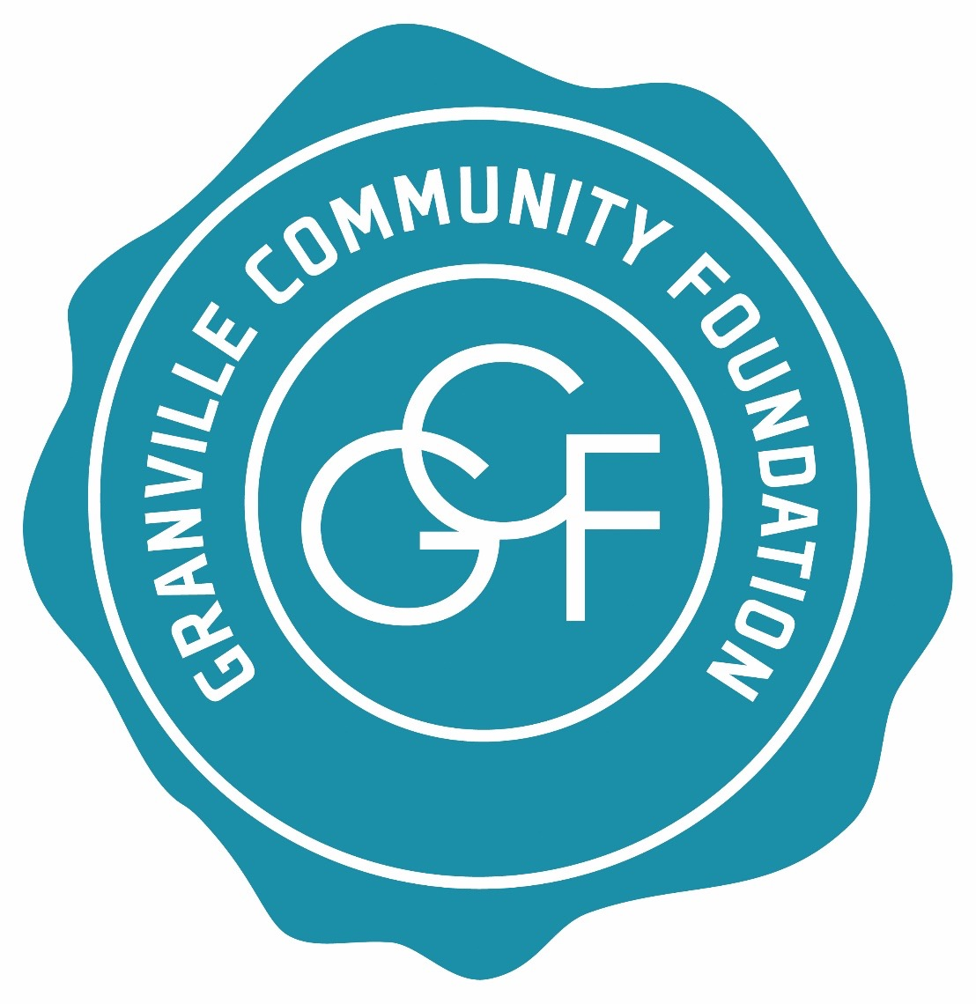

Granville Community Foundation
2018 GRANT APPLICATION CHECKLIST

APPLICATION DEADLINE
All applications for funding from the Granville Community Foundation during the 2017 grant cycle are due no later than January 15, 2018. Applications submitted after this deadline will not be considered for an award.
Applications may be submitted to:

Granville Community Foundation
PO Box 321
Granville, OH 43058-0321

OR by email, no later than 5:00 p.m., to:

granvillecommunityfoundation@gmail.com
APPLICATION CONTENT
All applications for a grant from the Granville Community Foundation during 2018 must contain the following information:

- A completed copy of the Granville Foundation's GRANT APPLICATION FORM and GCF Project Budget – Exhibit 1.
- A document labeled "ATTACHMENT A" that provides a brief statement of your organization's history, mission, objectives, and primary sources of financial support.

- A document labeled "ATTACHMENT B" that lists your organization's trustees or directors and its principal officers.

- A document labeled "ATTACHMENT C" that contains your organization's most recent annual financial statement, preferably one that has been audited.

- A document labeled "ATTACHMENT D" that lists your organization's current fiscal year budget including a summary of revenues and expenses.

- A document or documents labeled "ATTACHMENT E" that provide supplementary information about your organization which is directly germane to your proposal (optional).

1

