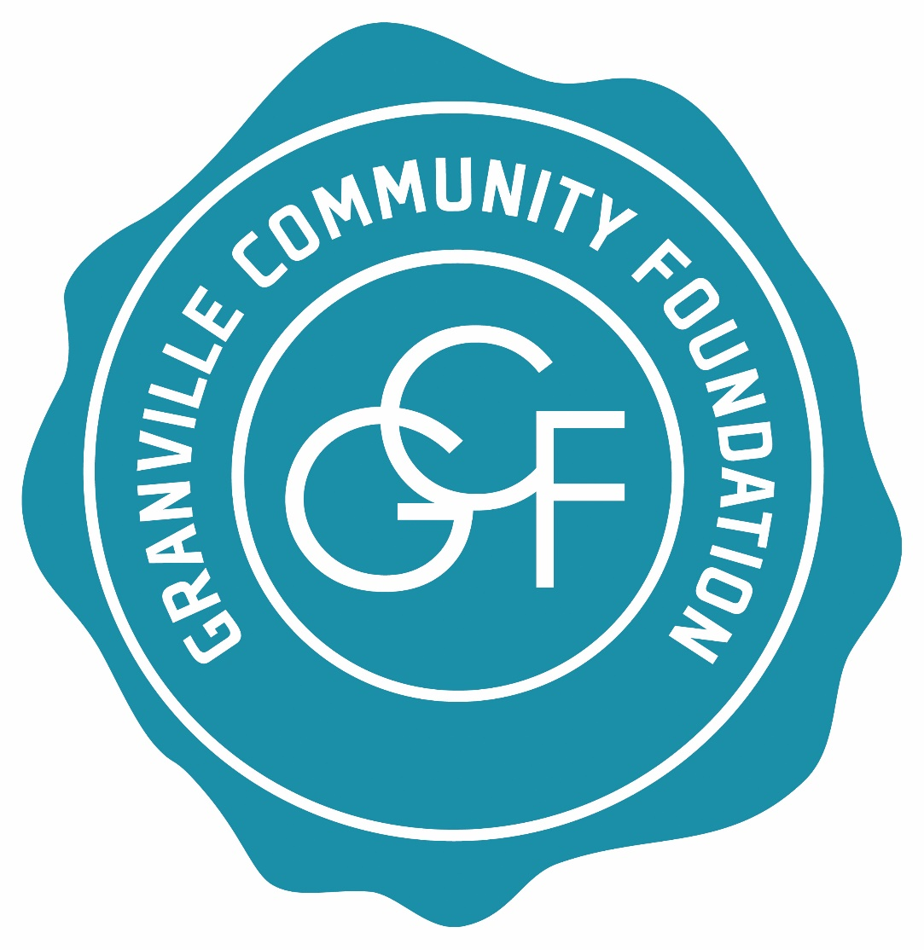

Granville Community Foundation
2017 GRANT APPLICATION FORM

Organization Legal Name: ____________________________________________________________
Organization Mailing Address: _________________________________________________________
Contact Name: ______________________________________________________________________
Contact E-Mail Address: ______________________________________________________________
Contact Telephone: _______________________
Name of Project, Program or Event: ____________________________________________________

Note: You may attach additional pages, as needed, but please keep your responses within the requested word limits for each question.

1. Is your organization a legal entity with non-profit 501(c)(3) status? ___ Yes ___ No

When was it founded? __________________________

2. Please describe the purpose, goal(s), and objective(s) of the program or project for which you are seeking support (maximum 250 words):

3. Why is this program or project important to Granville? In what specific ways will it improve the community’s quality of life? (max. 400 words)

4. How many people will be served or affected by the proposed project?

5. What is the proposed duration of this program or project?
Anticipated start date_______________ Completion date___________________
OR
Date of event__________________________________
6. What is the total cost of this project? ____________________________

7. How much financial support are you seeking from the Foundation? ______________________

Please complete the GCF Budget Form and attach as Exhibit 1. Include additional sheets (either within the Excel document or on separate sheets), if necessary, to provide sufficient detail in a budget narrative about your proposed expenditures and revenues to help GCF fully understand your project and your need for funds.

8. If your organization's primary purpose is religious, please indicate how your program or project will serve those who do not subscribe to your members' beliefs (max. 100 words).

9. To what extent do other Granville organizations provide similar services or activities that you are proposing to provide with grant funding from the Foundation? (max. 250 words)

10. Can your organization accept partial funding for this program or project and still meet its basic objectives?

11. If you are seeking support for an established program or project, how long has it existed and how has it been funded previously? (max. 400 words)

12. What specific efforts has your organization made to seek funding for this project from its own membership (if applicable) or other sources? Please describe other sources that have been approached and/or have committed funding to the project. (max. 400 words)

13. If this program or project is expected to continue for more than one year, how will it be funded in the future? (max. 250 words)

14. How will your organization collaborate on this project, if at all, with other organizations? (max. 250 words)

15. What specific outcomes must be achieved to determine this program or project as a success? What will be the positive result(s) of your project or program? (max. 400 words)

16. If funds are awarded, please describe how you will make local residents aware of the support that you have received from the Granville Community Foundation. (max. 200 words)

17. Please provide any other information that you consider pertinent to your grant request. You may also attach additional documents, labeled “Attachment E.”

18. All Granville Community Foundation grants recipients are expected to report within 30 days of completion of the project or event, or no later than December 31, 2017, on the accomplishments of the funded program or project. Please identify the person who will be responsible for fulfilling this requirement on behalf of your organization together with his/her contact information:

19. CERTIFICATION OF INFORMATION:
Name of organization head: _____________________________________________________
Signature of organization head: __________________________________________________
Date: _________

